Guide written by Limes5402
Proofread by Cursedsliver, Lookas, and Helloperson
Original guide written by Phlap

What is scrying?

Scrying is the act of casting Gambler’s fever dream to gain information about the next cast that would not be normally accessible otherwise. The guide will cover every form of scrying as well as confirming spells and their applications.

From this point on, all terms will be in acronyms to make reading easier. For the definitions, check the dictionary.

For a short list of commonly used ones in the future:

- GFD- Gambler’s Fever Dream
- FTHOF- Force the hand of fate
- RA- Resurrect Abomination

Why scrying works
Scrying depends on the fact that GFD takes information from the spell after its cast, namely the result, along with other forms of information. Keep in mind that information from a scry will be lost if a spell is cast or the game seed changes. For example, if GFD casts FTHOF and gives BS, the next FTHOF will give BS. The result of the next FTHOF may be changed if one of the following conditions was met/not met during the scry but was met/not met during the FTHOF cast:
- Being in the Easter or Valentines season
- Having the buff DF active
- Having a total building count greater than or equal to 10
- Having no unique building with a count less than 10
- Success/backfire status changed
For example, a scried BS may become another outcome if the buff DF is active.

The same applies to SE when it loses buildings eligible to be picked (although it can be very similar).

GFD’s result is based on the spell that it resolves on, not when it was casted. This means that it will have a different outcome if the spell count is altered before GFD resolves. This mechanic is referred to as GFD offset.

Applications & strategies
As the information regarding the spell’s outcome is not changed (other than success/backfire status or any of the other above conditions), finding a GFD that gives a certain outcome will ensure that the next cast of the same spell gives the same effect. This is the most basic version of scrying.

Ascension scrying
The most practical way of scrying for GC effects is through a method called Ascension scrying. Ascension scrying can drastically speed up the process as it allows the user to scry dozens of times per minute, as ascending refills the magic bar. Ascension scrying for FTHOF first starts becoming possible when the Grimoire is level 2.

The buff to scry for depends on the combo you’re aiming for (check the endgame combo guide for more information).

To Ascension scry, simply ascend, buy a wizard tower, cast GFD and repeat until you get the desired buff. Note that some outcomes may need confirming (see below).

RA confirm
RA confirm is the simplest and also the most well known way to range confirm. In its most basic form, it consists of casting RA while GPOC is not active, which will simply yield a message and does not consume any magic. The message content will then determine whether the next cast will backfire:
- “Unable to spawn a wrinkler!” - next cast will not backfire
- “Backfire! But no wrinkler was harmed.” - next cast will backfire
However, this prediction will only work with 100% certainty for successes if the spell is casted when the backfire chance is the same or less than when confirming (and vice versa for backfire).

RA confirmation may be used for nearly all situations, as there are not many situations where one is in the Grandmapocalypse and is unable to leave it. The 2 most common applications are for normal spell casting and ascension scrying. When casting spells, it is usually best to have no backfires. The best way to cheaply avoid a backfire is usually GFD or to cancel the GFD with FTHOF.

When Ascension scrying, any GFD that backfires is not confirmed to backfire if casted normally. These casts (usually EF and sweet) are called unconfirmed. They have a ~⅓ chance of being confirmed. If not confirmed, the scry becomes useless and therefore requires finding another one.

Keep in mind that some scries are only confirmed with SI and/or RB. Unconfirmed sweet scries still have a good chance of being saved by forcing the backfire chance to be as high as possible (usually through DO and a nat GC).

There are more applications of RA confirm (see GFD correlation).

Note: keep max magic below 101 for faster RA confirming.

Preconfirming
Preconfirming is a special variant of Ascension scrying that makes EF scries occur more often. It works by RA confirming before resolving, which allows one to offset casts to hopefully backfire, and keep any casts that will backfire, increasing the chances of a successful scry.

This route is for level 10 wizard towers.

Cheap spell: HC, DI
Medium spell: CBG, SCP
Free spell: ST, RA (ST will not be free if there’s a buff active)

- Ascend
- Cast GFD twice then RA confirm
- Depending on the outcome, do one of the following routes:
  - Cheap spell + FTHOF or FTHOF + anything: go to step 5, cast another GFD if unconfirmed
  - Medium spell + FTHOF: Cast GFD and go to step 4 if unconfirmed, otherwise go to step 5
  - SE + not SE or Free spell + cheap/medium spell : Cast GFD then go to step 4 (preconfirming can still be done here, with tight timing)
  - SE/Free spell + SE: Cast GFD twice, then go to step 3 (preconfirming can still be done here, with tight timing)
  - Free spell + Free spell: Go to step 2
  - Cheap/medium spell + cheap/medium/ST: Ascend
  - Cheap/medium spell + SE: Wait for resolve, cast gfd
  - Cheap/medium spell + free spell: cast GFD, base actions after from above
  - Free spell + anything: Cast GFD, base actions after from above
- Go one spell at a time (no preconfirms)
  - Free spell: Repeat this step (assuming that no buffs are active)
  - Cheap/medium spell: Ascend (this includes ST with an active buff)
  - Fthof: Go to step 5 (magic => 19)
- When FTHOF:
  - If not wrath, ascend
  - If not EF, ascend
  - If unconfirmed wait to check and ascend if failed
  - If confirmed, check without SI and/or RB
  - Keep if confirmed and adjust auras for casting

Note that this may be adjusted for other buffs such as BS (check for success RA, avoid clicking wraths, etc.)

Normal scrying
Normal scrying is a slower alternative to Ascension scrying, usually done during time consuming activities that don’t allow ascending such as Gaseous Assets, shiny wrinkler grinding, or gardening. The optimal spot to scry at is 17 magic (although other counts may be used for possible shiny scrying).

There are other hypothetical normal scrying routes, although their effectiveness have not been calculated. The unfinished route is here.

The other application of normal scrying is saving buffs for earlygame (usually before ascending for the first time). Earlygame scrying has the risk of not being able to confirm any spell, while being able to save a buff (usually CF) for the future. The method for scrying is to cast GFD then quickly cancel it with FTHOF unless the spell selected is also FTHOF or RA (unless this is done in GPOC). Keep in mind that using RA when a wrinkler can’t be spawned/popped will result in it being unable to cast. This results in it being effectively a free skip, allowing another possible scry.

If a GFD RA backfires, check if the next spell backfires. If it does, then repeat the process. If it doesn’t, either repeat or cast normally. See GFD correlations for more information.

Although it is technically possible to also skip ST, there is no reason to cast when ST can be skipped.

Midcombo scrying
Midcombo scrying is a general term for execution routes that involve scrying principles to either predict FTHOF outcomes or avoid DI backfires. This can allow for more optimized play and potentially duplicating BS.

A maximally extended/optimized version of midcombo scrying is often called “metascrying”, named after an execution route that optimized for maximal gains through scrying principles.

Range Confirming
Confirming refers to finding whether or not a spell will backfire, when it will, or which spell GFD will cast. Any casts (with one exception) that resolve without incrementing the spell casted count will give information on the backfiring status of the cast count it is on. This includes anything casted by GFD, successful SE, and RA - with ST without any buffs being the only spell that does not give such information despite not incrementing the spell count.

GFD correlations
One interesting detail about GFD is that the spell it chooses is directly linked to the backfire status of the cast count, where the “backfire status” is a number between 0 and 1. GFD picks a spell by seeing what can be casted at the time, compiles everything into a list, and divides the magic range to cast every spell evenly with Conjured Baked Goods at 0 - (1/(possible spells)) and Diminish ineptitude at (possible spells-1)/(possible spells) - 1 and the range required higher the further right in the grimoire menu it goes. Then, the game will cast whichever spell’s territory that the backfire status lands on. By finding where the backfiring status falls on the spectrum through predicting the backfire status via other range confirming methods, the spell from GFD can be predicted.

One peculiarity with backfire status is that it is inverted, e.g. a number of 0.9 correlates to backfiring with a backfire chance of 10% (0.1, or 1 - 0.9) or less, instead of 90% like one would expect.

GFD has another quirk, where its description is actually partially wrong: it doesn’t cast the spell selected with double the backfire chance, it casts it with a backfire chance of at least 50%. That means that any spell whose backfire chance is below 50% will be casted with a backfire chance of 50%, while any spell whose backfire chance is above 50% is unchanged.

The chances of GFD casting a certain spell may be calculated by seeing how much of the known range is within the range required of a certain spell. These charts may be used to estimate the chance (certain cases such as reality bending are omitted as the difference is too small to see):
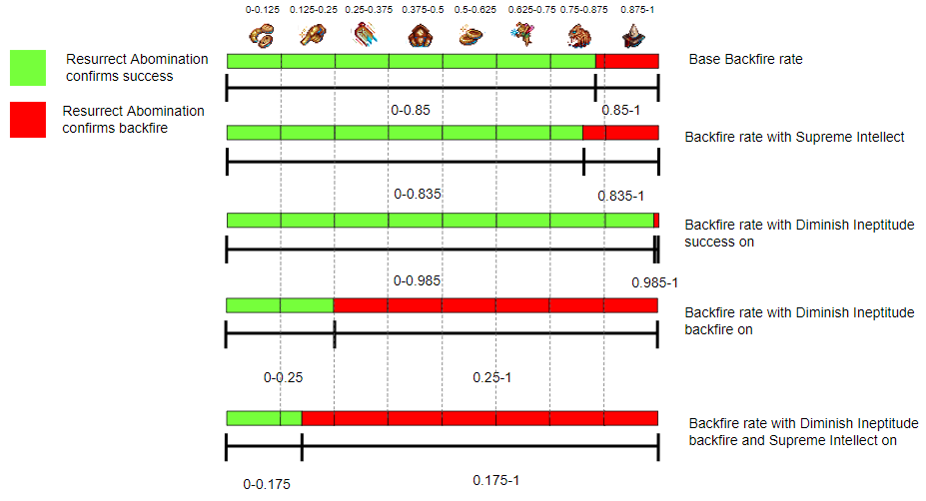
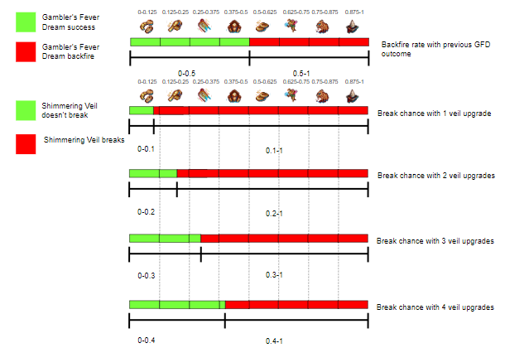

RA range

RA confirm has many other great applications beyond just confirming. For instance, modifiers such as SI can be used to narrow down the backfire range to very specific ranges that allow for much more predictable results. As a spell may backfire with SI on and succeed with SI off, this would mean that the value would be between 0.835-0.85 as (random number)<0.85 and (random number)>0.835, which can be used to further predict other outcomes. The effects are more noticeable with backfire DI, as the range opens up more and may be used to predict GFD FTHOF.

RA confirming is also used in nearly all grimoire routes for confirming the success of DI. In cases of backfire, either HC is casted or GFD and canceling with FTHOF if DI for avoiding a possible backfire. If RA, check for another backfire.

SE confirm
It is possible to confirm successes with SE, assuming that SE can’t be casted. It is much more risky, cannot predict backfires (uses magic and increments count if backfires), and overall not recommended except for if there is a genuine reason to not be out of GPOC.

SE confirm has only one real use - farming multiple shiny wrinklers. As stopping GPOC to use RA would pop every existing shiny wrinkler and delay wrinkler spawns for the next few minutes, SE would avoid the risk of popping the wrong wrinkler while being able to cast RA.

Veil confirming
Veil confirming is similar to RA confirming in that it can clearly pinpoint ranges, while having no risk. The shimmering veil is seeded so that its random number aligns with the grimoire for backfire range. The veil will protect itself from 0-0.1 with 1 veil upgrade, 0-0.2 with 2 veil upgrades, and so on. In order to veil confirm, the clicks of this ascension or GC clicks all time combined with reindeer clicks this ascension must align with the all time spell that is being confirmed for. For example, if on click x the veil doesn’t break with 4 upgrades, the backfire range on all time spell x must be between 0-0.4.

Veil confirming has applications in range pinpointing, grimoire execution, and confirming. As its random number is between 0-0.1 and 0-0.4 (depending on veil upgrades owned), this includes the range for force the hand of fate. The range with the most force the hand of fate chance is 0-0.3 (3 upgrades), although using 4 upgrades provides flexibility with more GFD confirmation.

The shimmering veil may be used to confirm the success/backfire of GFD. As the range for success for GFD is 0-0.5 and range for success of the shimmering veil is 0-0.4, both values align. When the shimmering veil breaks, its random number is 0.4-1 while gamblers fever dream’s is 0.5-1, which means that 83% of GFDs will backfire when the shimmering veil does not protect. This allows flexibility in knowing when to let spells such as SE and RA resolve along with when spells will (most likely) backfire.

Although there is no reason to, it is possible to confirm the veil with GFD.

Interspellar scrying
Interspellar scrying depends on finding the second call of spells, which is the x position of FTHOF in no change, the skin of FTHOF in a season, which building is picked for SE, and the type of wrinkler from RA. The random number is the same for each spell, and can therefore be used for predicting each other.

This table shows where each random call is created so that they can be lined up (calls between 5 and the second to last one are omitted as they are GC outcomes and may not be called based on the situation. Wrath cookie pools are omitted.):

Spell | Call 1 | Call 2 | Call 3
Fthof (no season) | Backfire number | X position | Y position
Fthof (1 change) | Backfire number | Golden Cookie skin | X position
SE | Backfire number | Building picked | -
RA success | Backfire number | Outcome (shiny or normal) | -
RA backfire | Backfire number | Wrinkler popped | -
All else | Backfire number | - | -

This chart may be used to estimate the chances of a shiny, picked building, etc. after interspellar scrying:
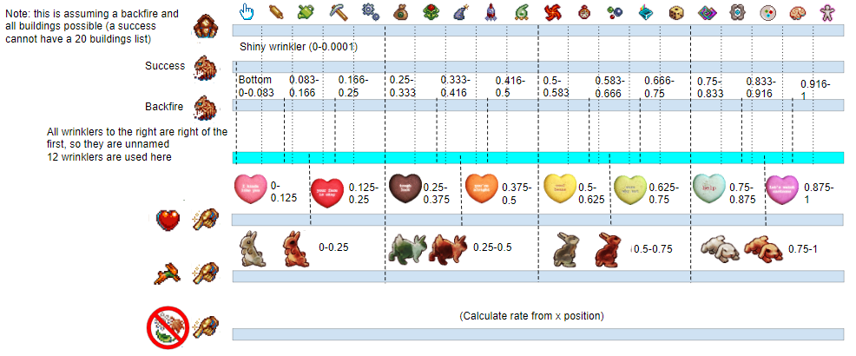
In the case of no change FTHOF, the x position starts from the left (0) and ends at the right. The x position divided by the number of pixels that the golden cookie can spawn in is approximately the random number.

SE selects buildings similarly to GFD selecting spells, in that it makes a list of every possible one and picks one based on the random number. The higher up a building is, the closer to 0 the random number needs to be to pick it. Keep in mind that some buildings may not be picked due to SE’s restrictions.

RA may spawn shiny wrinklers if the random number is below 0.0001. If it backfires, it picks a wrinkler similar to GFD or SE with the bottom wrinkler being the lowest and the one left to the bottom being the highest.

Applications

The only real application of interspellar scrying is for finding shiny wrinklers, as all other uses (such as finding the skin of a GC or building selected by SE) are useless.

The most precise method of finding a shiny wrinkler is through using the x position of a no change FTHOF GC as it can approximately give the random number.

In cases of backfire RA, SE, or 1 change FTHOF, only certain outcomes can provide a shiny wrinkler. For RA and SE, it must pick the bottom most wrinkler/top most building possible, and only specific GC skins can show that the next RA has a chance at being a shiny.

Although useless, it is possible to pinpoint the range of the second number through GFD offset.

FTHOF alignment scrying

FTHOF alignment scrying is based on ideas similar to interspellar scrying, but with looking at FTHOF’s many calls. As being in Easter or Valentines offsets the random call with golden cookie skins and some calls may not be included with certain conditions, outcomes may be further manipulated. The random calls used here are in this table: (note that this is every omitted call in the table for interspellar scrying. Call 10 does not give info in any relevant way and is removed to save space.)

Spell | Call 4 | Call 5 | Call 6 | Call 7 | Call 8 | Call 9
Fthof success, no change | Add 2 storms and 1 blab (<0.1) | Add building special (<0.25, skipped with <10 total buildings) | Replace with storm drop (<0.15) | Add sweet (<0.0001) | Pick outcome from list | If storm drop, randomize size multiplier (0.25+0.75*call)
Fthof backfire, no change | Add CUF and EF (<0.1) | Add sweet (<0.003) | Replace with blab (<0.1) | Pick outcome from list | - | -
Fthof success, 1 change | Y position | Add 2 storms and 1 blab (<0.1) | Add building special (<0.25, skipped with <10 total buildings) | Replace with storm drop (<0.15) | Add sweet (<0.0001) | Pick outcome from list
FtHof backfire, 1 change | Y position | Add CUF and EF (<0.1) | Add sweet (<0.003) | Replace with blab (<0.1) | Pick outcome from list | -

Note that the selection of buffs from the list is done the same way as GFD, SE, etc. with the buffs added first at 0-1/total buffs in the list and so on. The default outcomes of a success that are added are Frenzy, Lucky, and CF (removed with DF active). The default outcomes of a backfire are Clot and Ruin. Add the other buffs in the order that they are called (if rolled).

To see the calls in action, use https://yeetdragon24.github.io/Random-Call-Planner/.

Applications

FTHOF alignment is used for calculating the chance of any outcome based on the previous GFD. As the random number for the selected buff can be confirmed, they can in turn be used to calculate the probability of every other buff in every other case (such as taking success numbers to calculate the odds of a certain buff when the spell backfires, etc.). This is mostly used in routes such as Metascrying.

Keep in mind that the Y position starts at the top (0) and ends at the bottom.

It is possible to use GFD offset to gain more information with call manipulation between resolves (such as gaining the buff DF and clicking GC to turn backfires into a success), although these scenarios are rare and information gained nearly irrelevant.

Shiny scrying
Shiny scrying is the process of scrying for casts where RA spawns a shiny wrinkler instead of a normal one, allowing one to obtain more than one shiny wrinkler from one shiny wrinkler cast.

1 shiny

Shiny wrinkler farming for one shiny consists of casting RA, and trying to remove all wrinklers when casting to minimize the risk of losing magic through a backfire.

Multiple shinies
Shiny scrying is different from hunting a single shiny wrinkler as casting resurrect abomination has a risk of popping existing shiny wrinklers. This may be avoided through SE confirming.

The idea of shiny scrying is the same as normal scrying, where the previous GFD’s outcome confirms the outcome of the next cast of the same spell. This shiny can be “saved” for future wrinklers where it is more time consuming to pop wrinklers as there are less spots.

There are 2 routes for shiny scrying. Note that optimal magic counts for both have not been calculated.

Without veil confirm
- Cast GFD
- Depending on the outcome…
  - If RA, cancel with anything that works
  - If not RA, cast GFD and move to the next step
- Depending on the outcome…
  - If the first GFD backfires, cancel
  - If the first GFD succeeds, let it resolve

With veil confirm
- Scout for a veil break followed by a veil success
- Cast GFD
- Depending on the outcome…
  - If RA or all else, let it resolve
  - If SE, cancel.

Note that it is possible to find some cases where interspellar scrying is viable, such as with veil confirm and metascrying. Note that FTHOF and SE are the only spells that can be used safely.

Lump type scrying

Lump type scrying is an extended version of FTHOF alignment scrying, but with the lump type instead. As with veil confirming, the lump type uses the same seeded numbers as the grimoire itself and can therefore be used to confirm each other. Like veil confirming, the time of the lump fall (in milliseconds in unix time) must match with the spell casted. That time can be checked here.

As sugar lumps use multiple random calls, they may be matched with those in FTHOF alignment scrying (calls beyond call 10 are omitted and the check for reality bending always happens):

Click to show table (this is to save space)
Action | Call 1 | Call 2 | Call 3 | Call 4 | Call 5 | Call 6 | Call 7 | Call 8 | Call 9 | Call 10
Fthof success (no season) | Backfire number | X position | Y position | Add 2 storms and 1 blab (<0.1) | Add building special (<0.25, skipped with <10 total buildings) | Replace with storm drop (<0.15) | Add sweet (<0.0001) | Pick outcome from list | If storm drop, randomize size multiplier (0.25+0.75*call) | -
Fthof backfire (no season) | Backfire number | X position | Y position | Add CUF and EF (<0.1) | Add sweet (<0.003) | Replace with blab (<0.1) | Pick outcome from list | -
Fthof success (1 change) | Backfire number | Golden Cookie skin | X position | Y position | Add 2 storms and 1 blab (<0.1) | Add building special (<0.25, skipped with <10 total buildings) | Replace with storm drop (<0.15) | Add sweet (<0.0001) | Pick outcome from list | If storm drop, randomize size multiplier (0.25+0.75*call)
Fthof backfire (1 change) |  |  |  |  | Add CUF and EF (<0.1) | Add sweet (<0.003) | Replace with blab (<0.1) | Pick outcome from list | -
SE | Backfire number | Building picked | -
RA success | Backfire number | Outcome
RA backfire | Backfire number | Wrinkler popped
All other spells | Backfire number | -
Veil | Break number | -
Lump type (no auras or RB slotted and inactive) | Call for RB (<=0.1) | Add bifurcated (<0.1 base, 0.15 with HU) | Add golden <(0.003) | Add meaty (<0.1*GPOC stage) | Add carm (<0.02) | Outcome pick | -
Lump type (Curve or RB loop) |  |  |  |  |  | Add bifurcated (<0.1 base, 0.15 with HU) | Add golden <(0.003) | Add meaty (<0.1*GPOC stage) | Add carm (<0.02) | Outcome pick
Lump type (curve and RB loop) |  |  |  |  |  |  |  |  |  | Add bifurcated (<0.1 base, 0.15 with HU)
Note that the selection of lump type from the list is done the same way as GFD selection spells, SE selection buildings, etc. with the buffs added first at 0-1/total buffs in the list and so on. The pool always contains a normal lump and special lumps are added in the order they’re rolled after that.

Application

Lump type confirming has no practical application at all. As the spell that is aligned to the lump type is the time in unix time, all predicted spells require being at trillions of casts to actually use. Along with that, it requires casting at least a thousand spells a second to be able to keep up with unix time advancing.

It is also impossible to know the real harvest time without external tools, which means that predicting spells is also nearly impossible. This is further randomized by discrepancy, which is where Javascript lag causes the lump type calculation to be delayed (usually by a millisecond). This page goes into more on the matter.

If the lump timing and the spell count were to be aligned, the issue of extra loops being unpredictable would make the last 2 rows somewhat unusable as it is not possible to find which call introduced the lump type. There is no way to perfectly align chosen lump with the right calls to give any lump type other than normal or to find that some outcomes are slightly less likely than others.

Lining up the timing may be used to find the perfect time to manually harvest the sugar lump, but even this may have discrepancy affecting it.

Analysis of the chosen lump type may yield a tiny bit of information (such as the pool for EF and cuf/storm and blab being rolled).

